20160822 Trading

Monday, August 22, 2016

Markets traded in a narrow range.

Around 1443 pm, I don't know whether I should buy here. The issue is tomorrow morning I don't have advantage and currently the market is quite weak. If I get stuck here will it be worth it to hold through tomorrow's am is the question.

I would be willing to hold it if currently it is an all-day down scenario.

Wait until the market goes into a discount. Currently 9832.5/9821, still at 1 0.1% premium.

PM min is at 1301 and pm max is at 1350.

Currently this level is quite tasteless. A mediocre middle of the road level with not much volume.

50bps realized from 2 lots.

Tuesday, August 23, 2016

Markets were strong in the AM. New high was achieved at around 1012. Markets are stably on top of the closeY. Markets rallied about 60 bps so far. Good

1015: markets want to rally here very hard.

I joined in but the expected profit from this position is negative.

The reason for chasing this is not because I want to train agility.

Now the feel for the market is quite important. For the 10:12-10:15 period, one can see that markets want to go up.

Don't go against the amFirst10, which is very positive today, don't go against the recovery trend.

Yesterday market closed at a low percentile, today the rally immediately occurs without giving too much time for recovery. Markets start to be reluctant to go up here (@ 1026), longs have accumulated about 50bps of profits.

Markets losing steam around 1030.

Made a mistake yesterday, market closed at lows on Monday, should have held the position until today. A good place to stack up position was 955 today.

Level stabilized at around 1033. Level is too high not attractive.

Amfirst10 was up 40 bps for 000016! This is the most bullish amfirst10.

Markets start to take a beating at 1034 as positions consolidate.

Any money made in the AM is an extra gain, because key advantage is in the PM.

1044 market quickly recovered all of Monday's losses and goes into flat mode with 23 bps premium which wants to go up.

Few thoughts at this point (plateau) 1. no shorting against a strong amfirst10 and weak retPMCOY. 2. feel uncomfortable to buy at this level (almost 100%) This is towards the end of the morning session. 3.

Relatively weak afternoon, traded within a small range with a bearish bias. Morning price action has clearly exhausted active traders. There is half an hour to go which is historically positive.

The weakness was very apparently felt through the PM session. Markets started a panic selling spree.

The pm high was about 1301, and it was never broken. If it couldn't break out, then going down is the only route.

The market didn't move today, but I got screwed. When the market was insane, you didn't follow, but bought in when the market was going lower. 1411 was the last attempt at breaking the pmmax, after the failure the market just went crashing.

Market felt extraordinarily weak in the pm, i was sitting there staring at the market so I knew completely what was happening. It just didn't want to go up.

Signs of danger include low breaking around 1350.

I got my ass kicked today. Why is this? The index was up 0.22%. The level at which I bought was not preferential.

1. Session high time must break a certain time
2. session low must not break a certain time
3. Afternoon tends to trade in the region set up by AM. The first 2 afternoon trades were not profitable because these are above the middle of today's range.

Wednesday, August 24, 2016

Amfirst10 weak, very little volatility.

3147 trading at flat premium.

People are not enthusiastic.

H is in a clear downtrend.

1037 market is in a clear weak trend. There is one hour until AM close, with a negative amfirst10, tend not to pile up positions here. Yesterday the best place to pike up was around 14:44 pm, not in the morning. Slow dropping does not warrant buying – quick dropping warrants buying.

Low is broken here…feel vulnerable.

As expected, markets start to tank.

Cuing at 9805, can't even sell here. H is getting destroyed down 1.4%.

I was buying on the lows, but there is almost no space to do any trading. The circumstances are extremely tough for longs.

Recap:

Delta pnl -105, trade pnl makes up for the loss+t cost. The first few sells are good. The buys were too early. The buy near 1017 was catastrophic. Buy near 1100 was OK and could have been held to early PM. A trend usually lasts until session end.

Today it was very obvious that market didn't want to go up for the entire day.

Thursday, August 25, 2016

Market opened lower on the weak overnight US session. US had a disappointing property sales figure because people realize that rate hike is going to negatively affect the prices. SPX rallied for 6-28 to 8-15 rally was due to geopolitical risk reducing probability of rate cut. We see that during this period, HSAHP also took a heavy beating with H outperforming A by a lot.

Nasdaq showed a lot of strength following Brexit.

Fut trading at flat at open @ 9798.

HK actually opened higher, which is rather strange. I expected it to go lower.

Now the level is at a relative lows compared with yesterday's range,

Investors are liquidating their positions. There is huge selling pressure.

Time is now 1001, there is no sign of recovery at all. Index now can only head lower. Conditions are not regular – ammax at 9:30.

1314

They ammin currently is at 935, market was extremely panicky, now it is gradually making its way back. Morning liquidation reduces the volatility of the position which is good. **The buy was too early given you had no clue what was happening yet.**

1020 it wasn't able to break the high so forget it for the morning session. The buy at 928 was a miscalculation.

XU traders don't want to give up being long here @ 1023, quite a struggle to keep above 9770 area. I am barely able to cover the mistake I made @ 928. I am not going to buy anything here now… index is laying flat here with high still at 930.

Buy on fast droppings.

Afternoon is unclear. Ammax<Closey this is negative while yesterday's closing low percentile is a positive. Look for signs of panic. Panic was obvious this morning and around 1015 it was greed at which time I dumped all my positions. Around 1053, fut guys start buying. I am not a fan here.

As a general rule of thumb, most of the chasers will lose. About 1/10 of chasers will survive with cutting edge technology. The buy-low-sell-high people make a modest profit if done properly. The key profits are at panic/greed moments.

Market is holding on hard to this level but the weakness is apparent. The market is too long at this point. If there's no panic, there is basically no premium.

The rational for not buying is simple. If closey/open was not reached on a second try at 1015, it is basically hopeless towards AM close.

CF Jun13. Monday

1112 another round of dumping here. Buying at these levels is like catching a falling dagger. Level is now 9715. Anyone who bought Aug 15 would now be stuck. I don't want to take the risk here.

Premium back to 0.3%. It is quite persistent. There are some guys that think index will rebound but they keep getting slapped. Towards the end of AM, people are coming in to grab positions, pushing pd to 0.3. Any buying on the dip is quite dangerous atm. They keep pushing it until

Anyone who chased after 14:10 on Friday Aug 12 would be stuck.

PmFirst10 is slightly up. About 24% of the time, pmfirst10>0, and we are in that scenario. But the Sharpe for the pm is about 0.5, which is too slow to do anything meaningful.

Today the issue is you had no advantage at 9:29.

Afternoon's distribution is skewed to the negative. In the early PM, markets rose a bit but is not enough to draw me in. The main reason is the AM is way too negative.

1350 Market is moving up.

1355 Futs moving higher while cash stable.

1347 XU is waiting for the go-ahead to rally.

1438 Broke out of the range into 9790, traders chasing. PD 0.3. Performing worse than buy-hold. Now shifting into the Friday anticipation mode. It had been waiting for this rally for about 55 minutes.

1452 The last bit of strength is exhausted.

The rally up was much stronger than expected.

Problems today.

1. Buy was too early ( this was before anything was clear)
2. Selling point was good. (cannot trust on brreaking new highs)
3. in the afternoon, by staring at the market, it was clear it wanted to rally.
4. What I used a lot previously was using amMaxT and amMinT to estimate the expected max time.

Fut selling into discount after market, was going to buy 1 lot but entered by mistake and bought 2 lots @ 9760.

Europe opens weak following US and Asia.

**Friday, August 26, 2016**

Yesterday's afternoon was a good opportunity due to Wednesday closing at a low.

Markets fail to break at around 1005, sold the position.

1028: Market tries to break out again. All futs rallying. The AM low was around 947. The AM low suggests that it will be a oscillating session instead of a

1041 Another round of rally occurs here. The issue now is yesterday's rally is a bit strong. I feel uncomfortable holding here.

1114 At day's highs, waiting for the signal to rally at this point, at the highs.

Pm session: pmFirst10 was down 12 bps, given yesterday closing at 84% percentile,

1340 market trading @ flat @ 9767.

The move is a natural move to revert back to the middle of the true range about 9750.

One issue is that trading these days has made me a little oblivious to the most important deciding factor which is percentileYCat.

Upon a check, there is no advantage with

This week, I am flat after T cost.

This result is OK, as long as you can keep flat, that is a good achievement. You were able to escape the miserable Friday afternoon because retPMCOY was high. You didn't take advantage of the Thursday PM which presented a good opportunity. Generally, trading experience is growing. The key thing is a have an idea about what the market is doing. If you are sensitive enough, you can sense what the market is thinking about. Pay attention to a few key levels where if it doesn't successfully break, it is deemed to have failed.

Weekly review:

Flat performance this week.

**Tools to develop:**

Jolt monitor: Monitor big moves.

Email sender: Every 5 minutes, I want to know what the current percentile is.

Android phone monitor. (Phone app to monitor what is the current percentile and all relevant statistics).

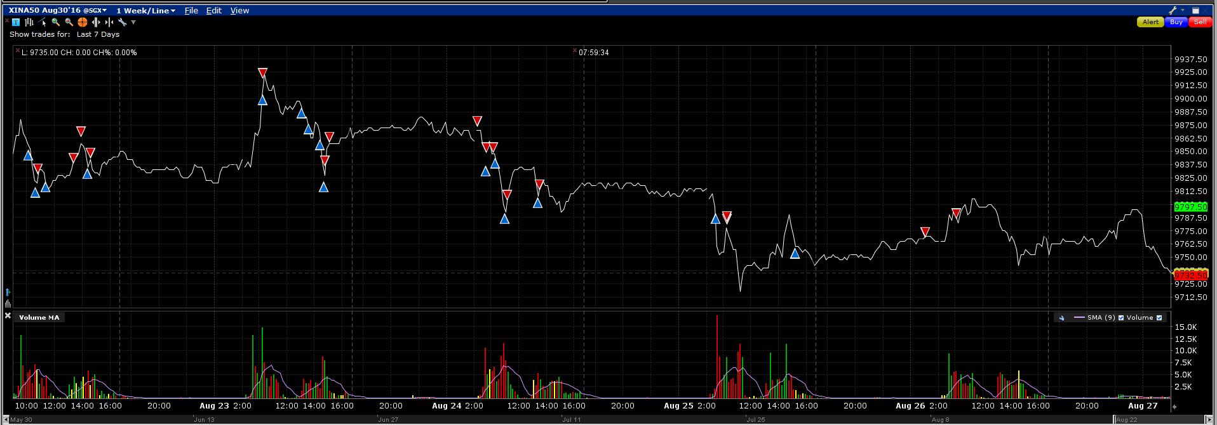

**Issues:**

Missed: Thursday there was a key opportunity to go long, there was a key advantage here but you were too focused on the small picture and you missed a negative

**Mistake:**

The buys in Tuesday afternoon were not consistent with buying at a low percentile.

The buy in Thursday AM was not justified.

**Done well:**

The T+0 trades were done fine. Friday afternoon was well dodged (based on the negative pmFirst10)

I want to monitor the live percentile and true range.

Some musings:

1. if market fails to rally, then it is more likely to go down. Reduce long position if market feels
2. Buying time is either at the beginning of AM or after 11am (if start breaking after 10, then the probability
3. Buying